SmartSuggest; Learn at Your Own Pace



*Christopher Celecia*

*John Iannacone*

*Paul John*

*Irvin Naylor*

*Pa Pa Oo*

*Nick Tolppi*

*ITIS-3130-001 Human Computer Interaction*

*May 3, 2019*

[SmartSuggest App Interface Link](http://app.buildfire.com/app/index.html?appId=a2e2c6c1-5b18-11e9-8fc5-06e43182e96c&mode=0)

# Table of Contents

**Table of Contents** **2**

**Need Finding** **3**

**Background / Questions** **3**

**Interview and Focus Group Study** **4**

**Interviews** **6**

**Design Goals** **13**

**Design Description** **13**

**Persona 1** **14**

**Persona 2** **15**

**Design Concept - user journeys** **16**

**Design Concept - wireframes** **17**

**Detailed Design - High fidelity prototype** **19**

**Evaluation** **23**

**Evaluation - Wizard of OZ** **23**

**Pilot Test - Wizard of Oz** **23**

**Recruiting - Test 2-6** **24**

**Experiment Design Pilot** **25**

**Evaluation - Usability experiment** **27**

**Total Participant Time Distribution** **30**

**Average Time by Button** **31**

**Conclusion** **32**

# 

# Need Finding

## Background / Questions

**4 sentences that describe the app**

Provide recommendations to parents on how to raise smart girls.

This app recommends fun activities and programs to parents to raise smart girls. The recommendations are for girls from preschool to preteen, and prepare them for a future in STEM. The app showcases the stories of important and successful women and girls to inspire future smart girls. Finally, the app showcases future opportunities of entrepreneurship, self-confidence, relationships, etc, to help parents navigate life with their smart girl.

**5 open ended interview questions**

1. Tell us about yourself?
2. What motivated you to take stake in this project?  
   What do you see as potential goals for this current project?
3. How would you define success of this app after it launches?
4. What features of this app do you think would be used the most?
5. What kind of monetization options are you considering, and how do you believe it will affect the user experience?

**10 open ended questions for the demographic of users**

What is the primary demographic? Parents? Middle schools girls?

Focus on parents who homeschool?

1. Do you consider yourself technologically proficient?
2. If so, what kind of feature you would like to expect to see in this app?
3. If not what features within a learning based app would make it easier to navigate?
4. How much time would you like to spend on the app?
5. Would you like to monitor the usage of apps and limit your children’s activity?
   1. If not, how often does your kid use a device on average?
   2. If yes, what apps does your child use? How often does your child use devices?
6. Why do you think parental control should be added in the app?
7. Is your child in a class that utilizes computers?
8. Does your child use technology currently? Phone? Computer? Other?
9. Do you have any education apps downloaded currently?
10. What kind of learning style would suit you the best?

**3 open ended questions for the focus group**

1. Did you teach your kid to use devices?
2. Have you used education apps before with your child?
   1. If so, how successful was it?
   2. If not, would you be interested, why or why not?
3. Which kind of apps you or your child currently use for education?
   1. Are you satisfied with it? If so, what is your favourite feature?

# Interview and Focus Group Study

1. **Who will lead the interviews and focus group: provide the names of the students that will do each of these. How many people will each person interview? How many will be in the focus group?**
   1. John - 2 Interviews
   2. Nick - 3 Interviews
   3. Chris - Interview(s)
   4. Irvin - Interview(?)
   5. Paul - Focus Group
   6. Pa Pa - Interview(s)
2. **How will you recruit people to be interviewed or in the focus group? How will you contact them and ask them to participate?**
   1. Nick - contact through email and phone to talk to interview people at my church and ask coworkers if they want to participate.
   2. Contact friends and family.
3. **How will you record and transcribe the interview and the focus group meetings?**
   1. Mobile recorder using phones.

What kind of recorder?   
A Good Transcription Software Program

Where will the transcripts be stored so the whole team can see them?   
Google Docs

1. **What will you say to start the interview or focus group. Be specific make sure that each person in your group that does an interview says the same thing.**

Give a brief overview of the site to the person being interviewed and give them the general idea of the project.

This app recommends fun activities and programs to parents to raise smart girls. The recommendations are for girls from preschool to preteen, and prepare them for a future in STEM. The app showcases the stories of important and successful women and girls to inspire future smart girls. Finally, the app showcases future opportunities of entrepreneurship, self-confidence, relationships, etc, to help parents navigate life with their smart girl.

1. **What is the list of interview questions (see comments on previous submission, update the questions based on the answers to your questions to Abi.)?**

Is your child in a class that utilizes computers?

Does your child use technology currently? Phone? Computer? Other?

What kind of learning style would suit you the best?

Would your child be interested in live tutoring help with computers?

1. **What is the list of focus group questions?**

Did you teach your kid to use devices?

Have you used education apps before with your child?

* 1. If so, how successful was it?
  2. If not, would you be interested, why or why not?

What are some of the apps and websites you use the most?

What other apps or tools have you tried out?

If you want to schedule an activity with your daughter, what do you do?

If your child has difficulty with homework, what do you do?

What difficulties could you see trying to interest your daughter in STEM?

Which kind of apps you or your child currently use for education?

* 1. Are you satisfied with it? If so, what is your favourite feature?
  2. What is the biggest pain point related to the current app?

## Interviews

Interview 1 John Iannacone:

John: Hello Miss Johnson this is John and I'm just trying to get a few questions answered in regard to a project that we are doing for a course at UNC Charlotte. which is to build an app interface eventually for most notably younger girls from the ages of three to twelve and I was just trying to get a few questions answered in regard to I guess you know various learning styles and things of that nature. the first question is is your child in a class that utilizes computers?

Miss Johnson: Yes um currently my child is in 5th grade and is learning how to do her keyboarding curriculum right now so yes.

Like that would be like those I guess the typing programs for like helping the younger children learn how to type properly?

Yes that is correct.

John: Now with technology does your child use any currently whether that be a phone a computer or a tablet?

Miss Johnson: Well since I’m a stay at home mom she doesn’t need a phone but she does use her tablet after all her homework is completed its an iPad for games and apps and stuff.

John: just a couple more questions what kind of learning style I guess would suit you the best as part of this whole idea behind this interface is to give the parents, a way to learn the things themselves and then you know help their child if they needed you know tips for studying or you know things of that nature.

Miss Johnson: Oh okay I don’t really do much homework but I would say I am more of a visual learner more visual I like to see things.

John: and then the last question I had for you with I guess this interface something that they're trying to decide on is I guess in regards to like a online tutoring help that will be like in a video recordings or other I mean what would be something that I guess you would like to see what that if you knew you were using that kind of service.

Miss Johnson: you know my child uses KHAN academy thats K H A N for her math tutoring what I like is examples and I like step by step so that you know I can also refresh my memory and she can go back and learn and practice problems especially with math practice you know and probably being able to get help whenever thats reliable 24/7 you know like I said she has a tablet thats easily usable on the tablet. really help with homework sometimes I get very busy.

John: I completely understand that it's definitely something that they're looking into with that that's all that I had question wise for you I appreciate your time with it and just thank you again thank you very much.

Interview 2 John Iannacone:

John: Hello Mrs. Stevens I'm John I'm a student at UNC Charlotte and I've got a few questions for you we are conducting a interview process for one of our classes and its going to be eventually used for an app interface for learning most particularly for girls age 3 to 12 focusing on younger girls and helping them you know I guess be better prepared with some of their school Endeavors I guess my first question for you is going to be in regard to if your child uses computers in the classroom currently.

Mrs. Stevens: Yes Sarah does use computers in the classroom she is in the 4th grade and she uses computers daily her teacher gives them both math and a reading skill timed tests to see where their strengths and weaknesses are.

John: Okay now to kind of follow up with that does your child use technology whether it be phone on a computer or tablet outside of school I guess kind of in the home setting.

Mrs. Stevens: Yes a lot of the teachers post their assignments and Sarah has to go online to find out what her assignments are if she has had some issues in class or I'm unable to help her then she will google to help find a way to solve the problem and she also uses a calculator to check her work.

John: Now this is more of a question kind of tailored to you is this app as you know once it's actually kind of I guess put together right now they're getting ideas but it's based around kind of your learning style because you know the goal with this is not only to help these younger children with some of their learning Endeavors but also I guess prepare the parents so that they can help the children you know if there are moments where they're struggling with their school work.

Mrs. Stevens: I am a tactile and a visual learner so pictures or drawings or writing out math problems those are my best ways to learn.

John: Okay and then the last question that I have for you is based around live tutoring help a lot of people today will use live tutors whether it's either Chegg or you know services like Tutor Vista things like that you know I was just trying to understand you know if that's something that you are particularly interested in or use you know your kind of against it I guess what are your thoughts on that.

Mrs. Stevens: Well when I can help my daughter with homework do my best and as for the live tutoring I would prefer more of a face-to-face as opposed to a computer I like the interaction and I feel that its important for students. like tutoring maybe if they had someone that they can visually see then that would be a possibility and be beneficial.

John: Well thank you for your help with this that was all the questions that I had for you and I just appreciate your participation

Mrs. Stevens: all right thank you John

Interview 3 Paul John

Paul: Hello, Mrs. John, this is just for a school project, y’know, I’m supposed to interview a person and ask a few questions for about a website that’s supposed to help you raise smart girls. This Iphone is going to be recording what we say, for the assignment.

Mrs. John: Okay, hi Paul, hi everyone.

Paul: Okay, so first question, and you’re going to have to imagine but, “Is your child in a class that utilizes computers?”

Mrs. John: Um, yes I don’t know. Is he in class? You’re not skipping, are you?

Paul: Haha, okay to clarify, for the interview, this is Mrs. John, my mom that I’m interviewing. Anyway, no I am not skipping class. I didn’t skip computer classes when I was a little kid, either, so no. I guess, that’s a yes to the question, then. Okay, next question: Does your child use any technology? And for these questions, just remember when I was a little kid.

Mrs. John: Okay, okay so. When you were a small, your dad gave you a gaming console, you knew how to use a, that razr flip phone right okay, and we have that picture on the fridge of you on the computer. Now, you use too much computer, but that’s now.

alright, so yes to that one. Um, so what kind of learning style od you think would suit a child the most.

Mrs. John: So, if you do it on the computer, it doesn’t really stay in the head as much, as an actual activity , so it’s much better to do an actual real life activity.

Paul: So this is the last question but, you know a child is going to have to learn about computers somehow, so would you be ok with live tutoring help or something.

Mrs. John: Well, learning about computers is important, but having a person physically next to you is much better than like over Skype.

Paul: Alright, thank you so much for the interview.

Mrs. John: Thank you.

Interview 4 Irvin Naylor

Irvin: Hi Mr McCarthy, I’m Irvin Naylor, a student at UNC Charlotte and for my human computing interaction class, we are conducting research for an application designed to help young girls, around the 3-12 age range get into STEM and computer science. I am looking to ask you specific questions regarding your daughter, Anne. My first question: Does Anne use computers in her classroom, or at least that you are aware of?

Mr McCarthy: Yes, she tells me that her teacher has had her class use computers for math exercises and her science class I think. Oh and she’s also doing keyboarding and typing exercises with these little games.

Irvin: I see, now does Anne use technology outside of school? If so, how little or how much?

Mr. McCarthy: Well, she does have a computer that she uses mainly for assignments and exercises. Her teacher posts assignments online and she has to go there and get the directions and things like that. Certainly a little more advanced than what I had, -laughs-

Irvin: Indeed, though of course with any assignment interface a student must use, their parent must know what’s going on as well. This research aims to see not only how to best serve the child but the parent too so when the child needs help, the parent isn’t left in the dark trying to help them. So now I have a question more for you here: How do you feel that *you* best learn?

Mr McCarthy: Well um, I would probably consider myself a..visual learner, yeah a visual learner for the most part. I don’t really want to do a lot of reading when I can just save time and just *see* what it is I need to do, you know? If it’s kind of app or something like that, I want to be able to instinctively know where things are and things like that.

Irvin: I see. Now, are you familiar with live tutoring services?

Mr McCarthy: Sort of, I’ve heard some good things about them.

Irvin: Would you feel a live tutor would be an effective way to learn a concept that someone’s having trouble with? How do you feel about that?

Mr McCarthy: A live tutor, I can see how it can work, it’s just that I feel there can be kind of a disconnect. If the student and teacher aren’t physically there, it might be harder to really get the concepts. Also, for students who don’t have internet or access to a computer, this could be a problem for them. I feel it can be a good idea but there are those kinds of things that should be considered. It would depend, but for Anne, I feel like she might like it.

Irvin: Okay, well that’s all of the questions that I currently have for you today, Mr McCarthy. Thank you so much for your time.

Interview 5 Christopher Celecia

Christopher: Hello Mrs.Ng, I’m Christopher Celecia, I'm a student at UNC Charlotte and I’m just trying to get a few questions answered in regard to a project that we are doing for a course at UNC Charlotte. which is to build an app interface eventually for most notably younger girls from the ages of three to twelve and I was just trying to get a few questions answered in regard to I guess you know various learning styles and things of that nature. the first question is is your child/children in a class that utilizes computers?

Mrs.Ng: Yes, my children are currently in 1st and 5th grade and her teachers makes her utilize computers on a daily basis for school work.

Christopher: Okay now to kind of follow up with that does your child use technology whether it be phone on a computer or tablet outside of school in the home setting?

Mrs.Ng: Yes, my children both use tablets, the eldest daughter in the 5th grade also has a phone and a laptop that she is getting ready to use for Middle school. Both children have limited time on the devices until they get their homework done.

Christopher: what kind of learning style would suit you the best as part of this whole idea behind that the interface is to give you the parents, a way to learn the things themselves and then you know help their child if they needed you know tips for studying or you know things of that nature.

Mrs.Ng I’am more of a visual and then execution type of learner, I prefer to see something done then try and do that thing myself.

Christopher: last question that I have for you is based around live tutoring help. A lot of people today will use live tutoring services. Are online tutoring services something that you are particularly interested in or use? Do you have any negative thoughts on online tutorings? What are your thoughts?

Mrs.Ng I personally would like to look more into online tutoring, currently we have been using on site tutors over online tutors but I can see how having an online tutor would help. I would be open to learning more about online tutors and the benefits of having one in the chance we cannot have a tutor come onsite or go to a tutoring center.

Christopher: Much appreciated for your time and participation, Mrs. Ng.

Focus Group Interview

Paul: Alright good afternoon everybody to start off my name is paul and thank you all for taking the time to be here today. We will try to make this quick as we can so um to begin our main focus is really to find out ways that you and your children use technology and how we can tailor our project to reflect that. And um the the main idea of the project is to help girls age 3-12 find their niche in computing and give you all the tools to deliver a fun learning experience to them. To start out just a raise of hands who in here taught their kids using technology like whether that be home school or just in general. Okay a pretty good amount now I want to start with you Ms. Hutchinson what did you use to teach your kids.

Ms. Hutchinson: well for me really I am a stay at home mom so like I thought you know it would be better for my kids to learn at home.

Paul: alright I completely understand. Now who all wants to chime in. Yes Mr. Medley

Mr. Medley: yeah so for me I just didn't want my kids glued to the tv all day. Now I know that's becoming harder these days but like I thought the best alternative was going to you know be a learning app of sorts.

Ms. Gwen: Yeah I completely agree with Mr. Medley there he really brought up a great point that it seems a lot of kids just want to sit in front of a computer.

Paul: Okay great anyone else want to chime in? No okay we will go ahead and move onto our next question. Kind of building on what we last said who all have used you know education apps with your child? And did it help or not so much? Yes Mr. Jones you had something to say?

Mr. Jones: Yeah so for me being really busy and um you know at work for a lot of the day it definitely really helps to have a form of entertainment for the kids. Like it really truly helps a ton and it has helped to the point that both my son and daughter were able to skip 3rd grade.

Ms. Gwen: Wow that's really really is impressive.

Mr. Green: I just wanted to chime in I really do not find a use in these I guess really apps for a few reasons. Like um I guess it seems there are ways to teach your um kids without the need for all the extra technology stuff computers or such. My kids seem to really do pretty well pretty good.

Paul: Very good points everyone. My next question is um I guess like 2 parts both tie into each other. For one what apps and websites do you use the most often and what other apps or tools have you tried out?

Mr.Jones: Yeah so it’s a bit mixed I like to use Netflix and watch it in um my home theatre while the kids are playing in the house. I think uh that they have some learning app that it that they use pretty often.

Ms. Gwen: Do you mean the Leapfrog app?

Mr.Jones: Yeah so it’s something like that I know my wife should’ve been here she knows uh yeah. Other than that they love the tablet hahaha.

Ms. Hutchinson: I like to um use my kindle to read you know on my my tablet, huh yes it’s really good right.

Paul: It is really useful uh I don’t use it personally but I know quite a few who do. Anyone else want uh to chime in on what they use? Yes Mr. Medley.

Mr. Medley: For me yes I use youtube a lot for work and it’s really actually useful even for a hobby like woodcutting.

Paul: Okay, wonderful. So the next question is uh if you want to schedule an activity with your daughter, what do you usually do?

Mr. Green: Yes so if I want to schedule something for my own daughters what I do is I check the newspaper and I look at the listings being like, “Hey, what’s this is this good?” and if it is good i'll ask my wife and schedule a time for my daughters.

Mr. Medley: You know these kids these days all with the technology they’re just so fast at picking things up a my daughters actually come to me saying, “Hey daddy can we go do this and that.” so if it sounds good then I’ll agree but usually it’s them bringing it up and they’re usually on top of that.

Ms. Hutchinson: Usually I’ll talk to the other moms to see what should I do for the kids and we track info on like what’s cool and new and fun to do.

Paul: Alright, alright, so I have the questions here and this one and this is the next one, okay if your child has difficulty with homework, what would you do?

Ms.Gwen: right so I would definitely spend so much time with my kids on the homework because it’s important to their future I mean what should a parent be but supportive of their children.

Mr. Medley: Right I agree Miss Gwen. I actually am and I’ve been trying to help my kids but they don't want any help because they want to do it themselves and that such a young age that they don't really need to get tutelage, but I think that’s exactly why we could us an app because then they’d be getting help but instead thinking that they’re doing it themselves.

Mr. Green: Yeah I agree with um Mr. Medley. My kids are just so amazing they do so much on their own it's almost like they don't even need me and I make sure to check in on them on the weekends but for the most part they’ve been handling it just fine.

Paul: Well, I’m glad I’m in the presence of such supportive parent and thank you for letting me get an insight into your thought process and um that’s all the questions so I thank you for your time and this has been uh would you mind saying your names please?

Ms. Gwen: Ms. Gwen.

Mr. Medley: Mr. Medley.

Mr. Jones: Mr. Jones.

Ms. Hutchinson: Ms. Hutchinson.

Mr. Green: Mr. Green.

Paul: And thank you very much for letting me interview you.

# Design Goals

* Connect parents and their daughters with STEM resources that seek to uplift and help young girls get into Computer Science
* Help parents be more aware and involved in their daughter’s education by highlighting articles, events and other measures of involvement.
* Get information about outdoor activities or workshop for her children to participate those activities.
* Interaction and involvement from the child and the parent
* Easy to use interface for even novice computer users
* Accessibility for individuals who necessitate those features
* Easy to navigate search function
* Intuitive help features if you get stuck

## Design Description

**Usability design principles:**

* Make the app simple to use
* Maintaining consistency

**Consistency:** Consistency is the essential rule in creating design. Maintaining consistency provides user to have a better user interface. In addition, it helps the user to remember the patterns. Consistency layout allows the user to use the system proficiently.

**Color:** To have a use-friendly experience, color schemes should be in fairly simple with the limit of number colors which are not more than four.

**Recognition rather than recall:** Providing possible topics from a list of option would help to increase the efficiency.

**Major purposes of the app:**

* Provide resources for parents that help them raise smart girls
* Building simple and easy app for parents
* Parent Engagement in digital age helps to bring positive impact on their kids’ education

### Persona 1

**Demographics:** mid 30’s to low 40’s, middle class

**Motivation:** both trying to help their daughters understand things more easily

**Beliefs:** believe that helping their daughters is important but are somewhat unsure how to do some computer stuff

**Goals:** improve their own computer knowledge and help their daughters learn more easily

**Frustrations:**

-people rushing through information

-not really understanding the computer stuff that well.

**Name:** Mrs. Stevens

Miss Johnson

**Occupation:** stay at home mom and engineer

**Highest Degree:** Bachelor

**Age:** 35 and 42

**Story:** Miss Johnson has always struggled with understanding how to truly help her daughter with computer based school work. She really wants to help but isn’t sure how. Mrs. Stevens is an engineer and understands computers based on her work but isnt really sure where to start with helping her daughter more in this regard. She feels face to face tutoring is best.

**Computer use/Technology:**

- wants to learn more

- does not feel that online tutoring is needed

-other feels that online tutoring should be available 24/7

**Daily Activities:**

-Coordinating appointments, working at engineering firm

- working at home business

**Hobby/Interest:** running, tennis, swimming, diy projects

### Persona 2

**Demographics:**

Middle aged stay at home mother.

**Motivation:**

Making their child more outdoorsy. Not wanting children to become lazy.

**Beliefs:** Believes the right upbringing will lead to success later in life.

**Goals:** Make sure their child is active and have friends.

**Frustrations:**

* Children don’t go outside enough
* Children pay too many games
* Hates websites that are too brightly colored.

**Name:** Yuki

**Occupation:** Stay at home mother

**Highest Degree**: Bachelor

**Age:** 45

**Story:** Yuki grew up in Japan with a moderately wealthy family who owned a business in advertisement. Popular and growing a wild streak by the age of 14, she moved to Hawaii to see if she could survive there just for fun. A few years later, she started meeting a speedo-wearing military man named Tony after her college classes. After getting married, she had a son in Hawaii. Her degree is in Interior design, and after moving around due to being part of a military family, she wants her son to be as active and popular as she once was.

**Computer Use/Technology:**

- Doesn’t like overly complicated and colorful websites and apps.

**Daily Activities:** Taking care of children, reading, and watching TV.

**Hobby/Interests:** Painting nails, reading romance Mangas, watching Japanese game shows, and talking about the news.

## Design Concept - user journeys

**Mrs. Stevens**

* Age: 35
* Engineer
* Masters Degree
* Description: Mrs. Stevens is an engineer and understands computers based on her work but isn’t really sure where to start with helping her daughter more in this regard. She feels face to face tutoring is best.
* Other Sites: Amazon, company site, youtube, email
* Goals and motivation:

Help daughter better understand material and help her find information

**Mrs. Yuki**

* Age: 45
* Stay at home mom
* Bachelor's Degree
* Description: Mrs. Yuki is a stay at home mom originally from Japan. Her degree is in Interior design, and after moving around due to being part of a military family, she wants her son to be as active as she once was.
* Other Sites: Youtube, email, personal business site, Google, Hulu.
* Goals and motivation:

Make sure their child is active and happy with friends. Hoping to better understand the app

## Design Concept - wireframes

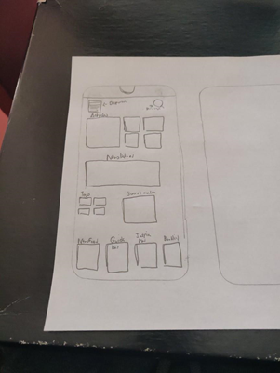

●When the user first opens the app, this screen is what they see.

●A home screen displaying all the necessary options

●A foundational point for all users

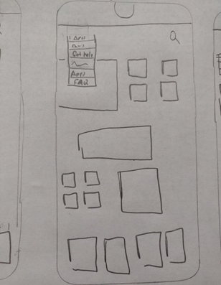

* Drop down menu is shown for the user

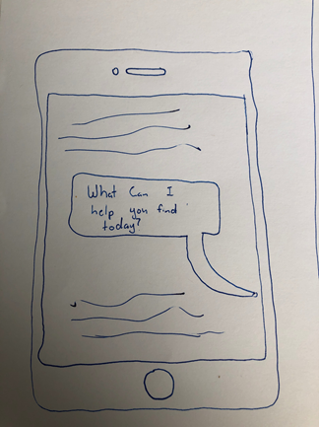

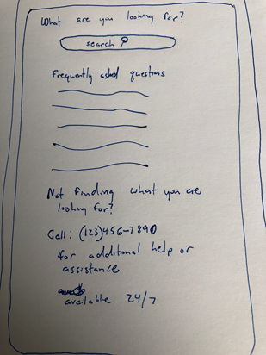

* Help function from a professional to ensure that even users who may not have the best knowledge can still use the app to its fullest potential

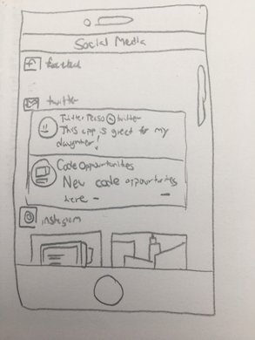

* social media section to connect with other parents to get ideas of what to do with their daughters

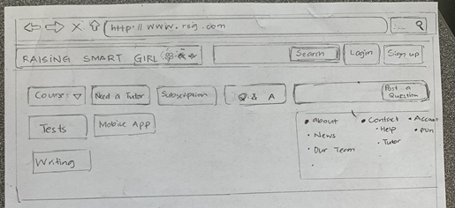

* Uses website to also help find apps in which the parent can download to their phone.

## Detailed Design - High fidelity prototype

**Features needed in prototype**

* Login
* Search Functionality (similar to reddit or Amazon style)
* Search page and search results page
* Clicking on info pulls up more options
* View site reviews
* If there is inactivity on the app it will prompt you to save progress
* Banner at the top (notification settings)
* Drop down menu
* Notification options
* Social media options on site (imbedded in page and for messaging)
* Help page if you get lost

**Layout ideas**

* Easy to see buttons and tabs
* Centered icons
* More important info is larger
* Drop down menu with links to sources
  + Bread crumbs to go back to main page/previous pages
* A clean color palette mostly white, grey and light blue

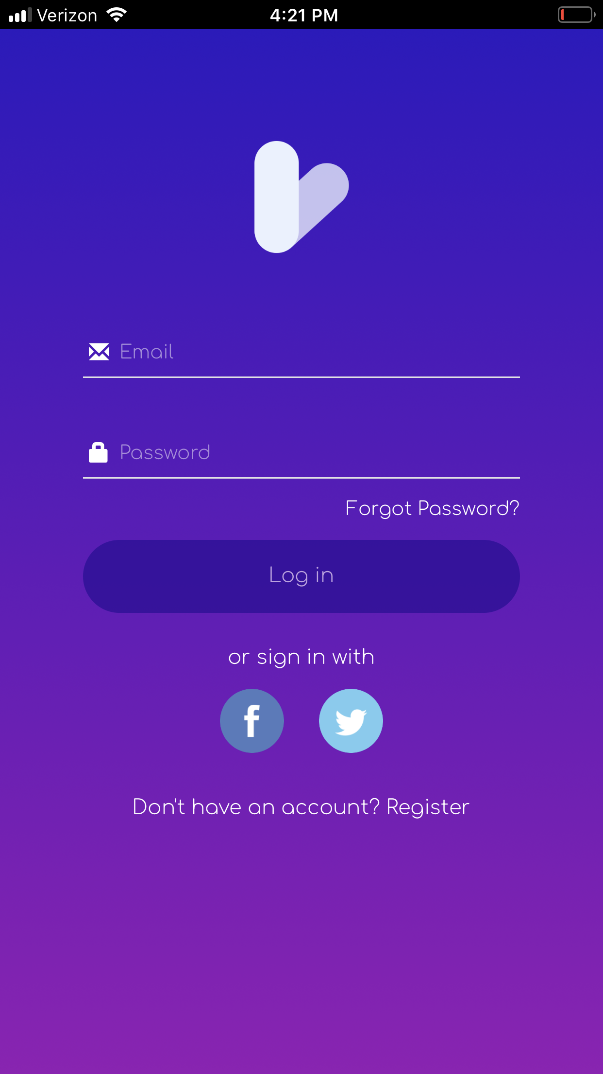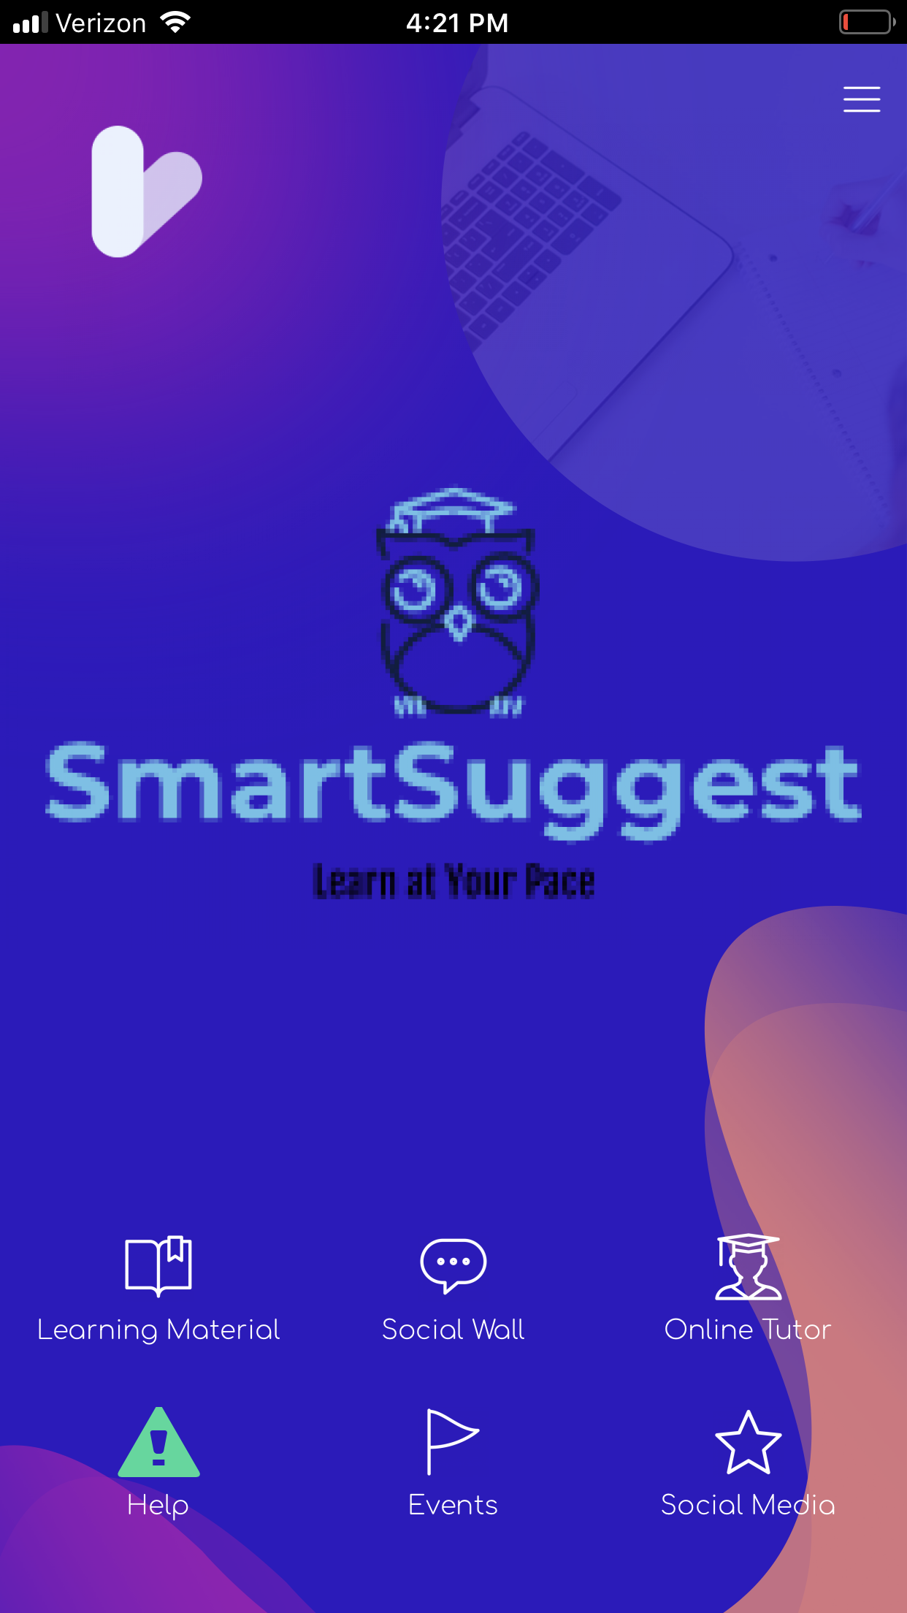

Above is the login page for the app where it is possible for the user to either log in to a pre-existing account or to create a new one. It is completely free to sign up. Next once you login is the homepage which is made to be easy to navigate with easy to read and identify icons. We went with a minimalist design that incorporated the things we felt the app needed while keeping things modern.

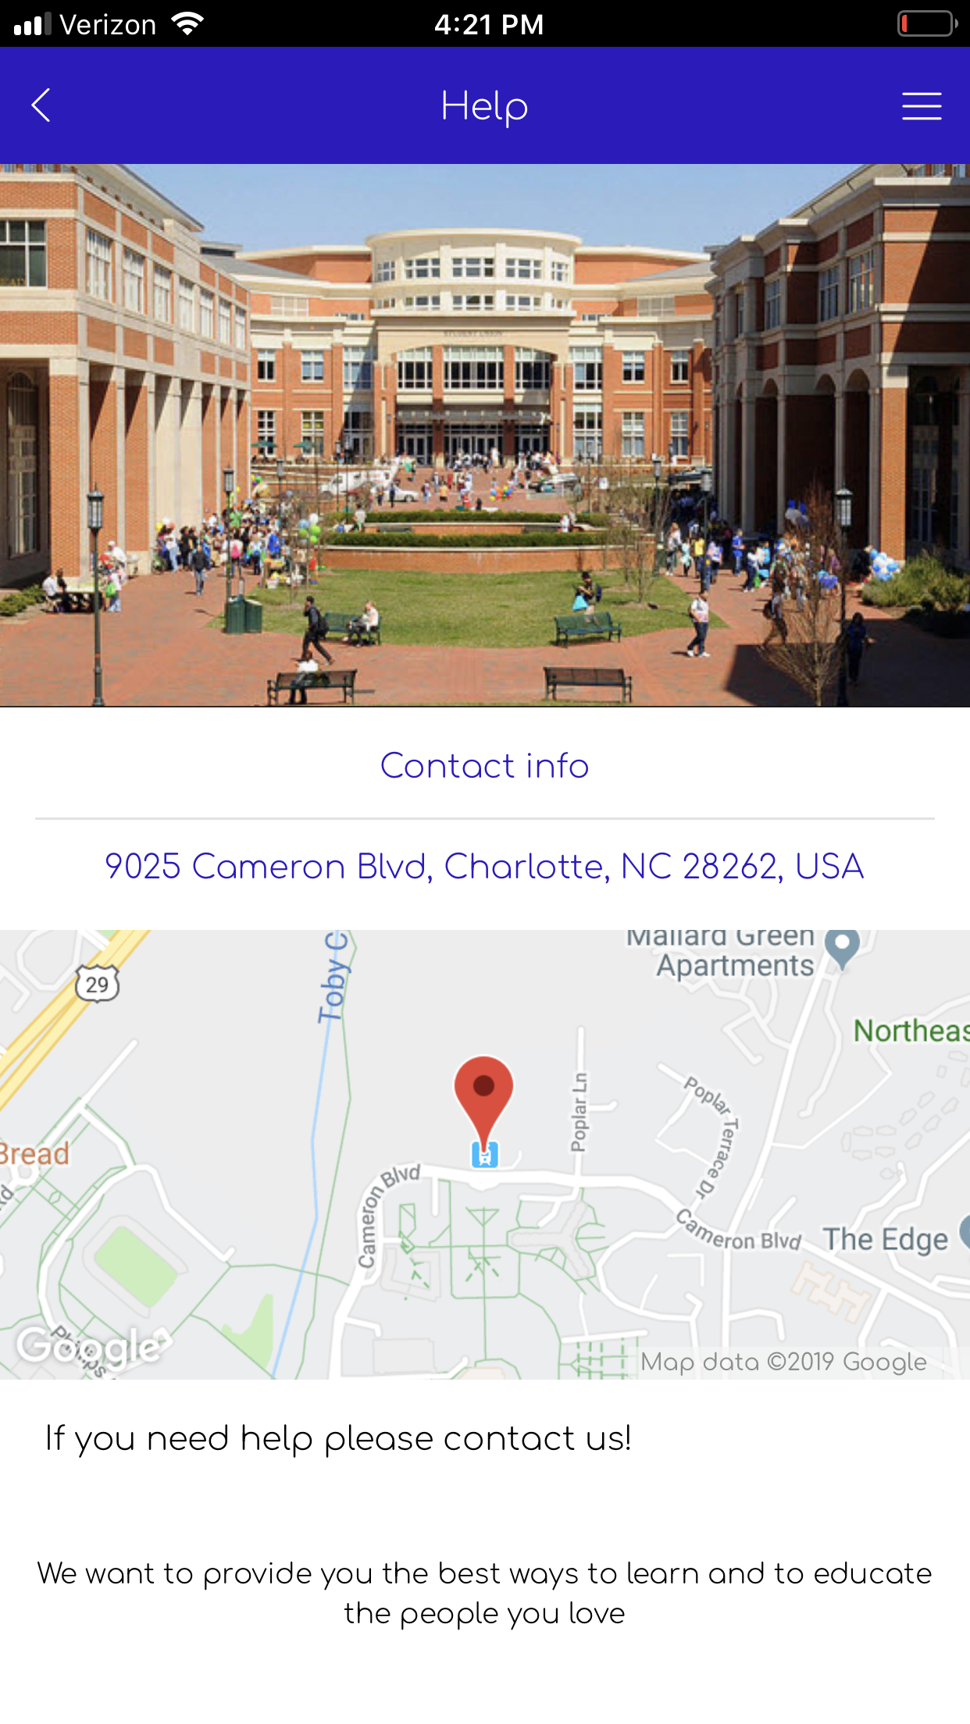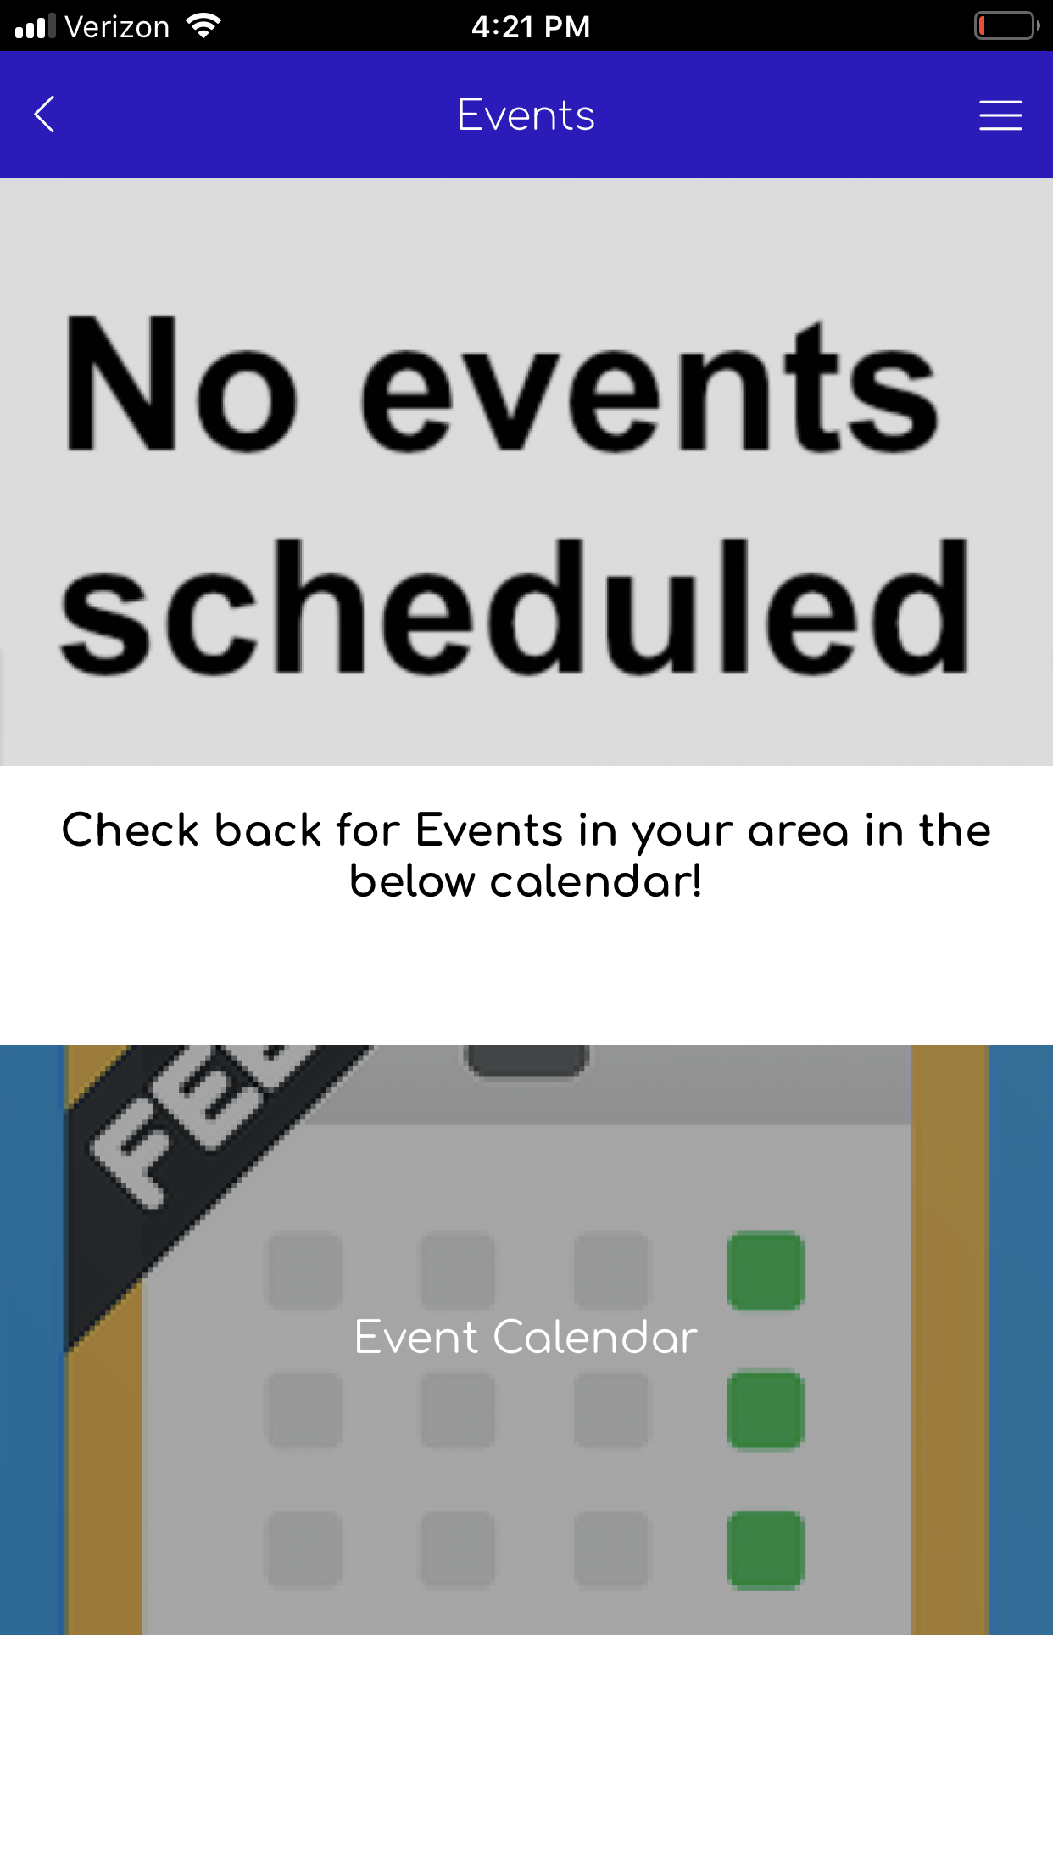

Above on the left is the help page. We felt this was an integral part of any user friendly application as we found that during our interviews that people wanted a way to get help fast if they got lost. The page is very simple, contact info first, then the address, then a map followed by a brief message. On the right is the events page which we felt was necessary especially for an education based app. Here people can keep track of events as well as schedule their own reminders in the calendar.

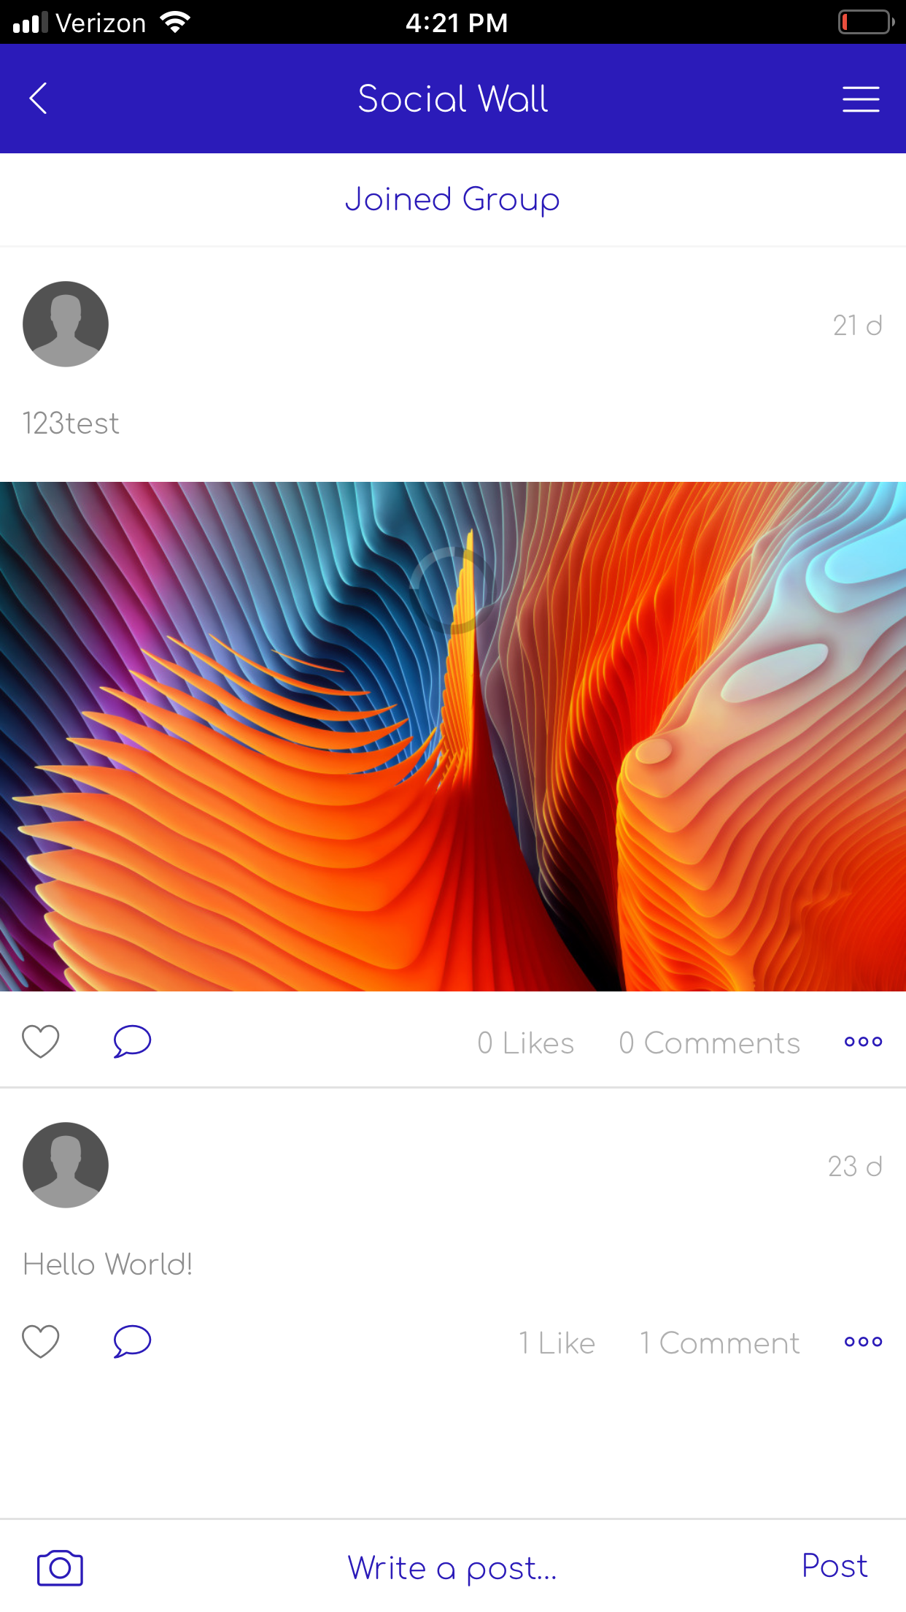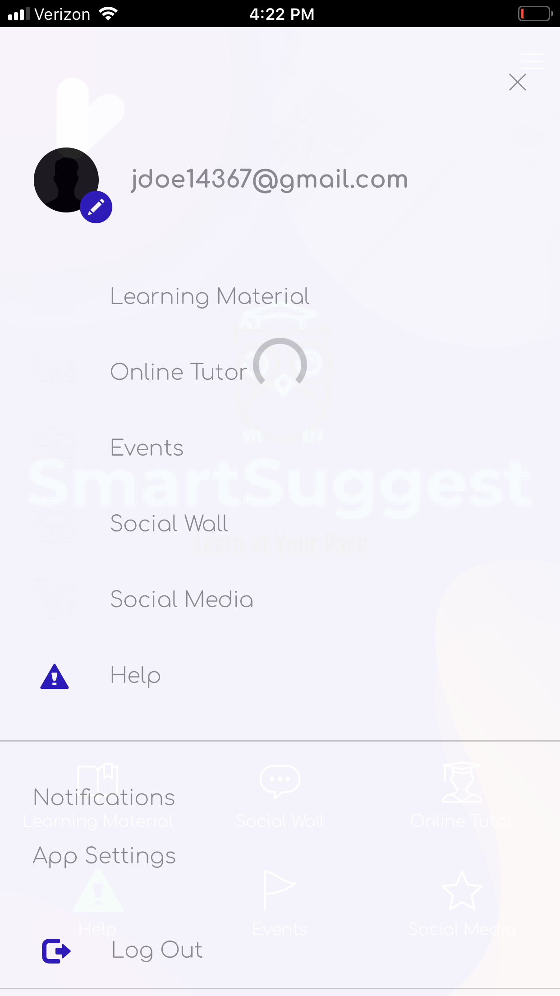

Above on the left is the social wall page. Here if people did not want to have to speak to a representative, they would be able to make a post or find other posts that could answer their own questions. It was also made as a way for people to connect and learn from each other. On the right is our drop down menu. This is simply a continuation of the home page and encompasses the same material with a few other items added. For one it lets you know who is logged in. It will also allow you to change notification settings and app settings through this menu. Finally when you are ready to leave the app you can simply log out.

# Evaluation

## Evaluation - Wizard of OZ

Through the Wizard of OZ study we were able to understand what each user might want to see within a app interface as well as what features they look for. Based on the results we were able to make adjustments to our app interface which in turn helped with the usability of our application. Our main priority was to build a app interface that worked well and was intuitive for all users of any age.

## Pilot Test - Wizard of Oz

(The following is our directions to the user. They are intentionally slightly vague because we want to see if the user can intuit the proper steps, and thus see if our app is intuitive; one of the hallmarks of HCI design.)

a. Login app (assume user already has account)

i. Input user name

ii. Input password

b. Try search for a desired event/activity

c. Check for messages on your social wall

d. Read lectures that user is interested

e. Click on the help option

i. Try find the contact phone number

f. Click on “Option” for more features

g. Close the program

For each step, we will ask the user to explain what they see on the screen and what is their thought process, while we record their thoughts via the iPhone’s microphone.

Afterwards, we will debrief the user with these questions and record their feedback:

Debriefing Questions:

1. Did you understand where to go to accomplish your tasks?

2. Was the application’s structure intuitive?

3. What would you say is a strength of the app?

4. What would you say is a weakness of the app?

5. What could be an improvement for next time?

6. What do you think about the consistency in the app?

7. How did you expect that to work?

8. Is there anything you’d like to share about the app or your experience?

9. How easy or difficult was that for you?

Results - Pilot Test 1

* User was confused, assumed there would be a search bar. Got it eventually.
* Instantly could check for messages for the social wall.
* User could instantly find lectures they were interested in. User asked if what format the lectures would be if they clicked on them. They liked the organization of the content.
* User was confused when asking for help, wondered if they should use the dedicated help on the home, or the help on the hamburger bar. He played around with the google maps features and played around. (both feature giving the same information – combination might be better)
* User commented that the “about us” and “help” were so similar, they were confusing. It would be more convenient to combine them.
* [at this point the user is exploring the app, asking general questions about what each button does. In particular the “classes” button. He wants to know the difference between the lectures and classes buttons. He finds it confusing because classes typically give lectures, so he believes they should be combined. That way, he can go to a class, and find a dedicated lecture.
* Furthermore, he asks clarification of the events tab and how it works. John is describing how the user should eventually, be able to register for events.
* The user comments that, especially as having superfluous options takes up two pages, that they should be combined.
* The user asks what kind of notifications they would get. John describes that the user would could toggle if they get a notification when they get a message.
* The user suggests a rewards system, where if users use the apps, they get some rewards, like coupons. Something to motivate the user.
  + Face to face live webcam, so users can ask questions immediately when someone is lecturing
  + Most relevant features to set in the first place
* The user asks for consistency in the help bar, as only the “Help” option has a picture, where as if all the options had an icon, even someone who couldn’t read the options could tell which options does what.

# Recruiting - Test 2-6

* For recruiting new testers, because of the link being able to work on any device, we plan on downloading it to our devices and recruiting testers who are willing to try it.
* We will ask the same questions as we did the pilot, ask them to think out loud, and ask them debriefing questions.
* We plan on looking for a variety of tester technological backgrounds. As there are 6 students, and we will all try to find a different tester, we believe we can find enough testers for this app.

## Experiment Design Pilot

1. **Goal(s) of the experiment**: List the goal (s) of your experiment, for example: compare design A to design B and measure which one is easier to use. Be specific!

The goal of the experiment is to test whether or not icon placement and naming convention plays a role in the useability of the app interface.

1. **Methodology:** specify if you are using abetween or within subjects method plus justification for your choice

The way this test would be conducted is as follows. We would begin by having the control with the help button on the home screen. Next after these tests are conducted we would remove the help button from the home page and only have it in the drop down menu. This would be able to test from a usability standpoint if it is intuitive.

1. **Participants**: specify how many participants, what is the target demographic, how will you recruit

* One Participant in class
* Aiming for 5 - 10 participants (over weekend)
* Target demographic will be people who are both familiar with app-based

interfaces and those who are not

* Recruitment will be done by asking

1. **Protocol**: describe the tasks, if you need to counterbalance, what will you tell the participants, what will you ask them to do, the questions for your debrief.

* Give task in game
* We will explain that the objective is to find the help icon as quickly as possible.
* The person will be timed
* The user will begin the experiment and try to find and click the “help” icon. Where the image for the icon changes each time.
* We will be recording how much time it takes for each user to find the “help” icon.
* Afterwards, we will ask the user debriefing questions.
* Finally, we will thank the user.

1. **Data Collection:** what data will be collected (verbal data, timing of tasks, answers to questions), how will it be collected, where will the experiment be held?

Invision game developer used to create a pages platform that will be timed.

1. **Data Analysis and Interpretation:** How will you analyze or aggregate the data, how will you interpret the results, how will you know if you achieved your goals?

* How long did it take participants to find the button?
* Measured time how long it takes a participant to find the button, how did the participant feel when finding it, and which position of the help button was the easiest for the participant?
* Which icon the participant preferred?
* What do participants expect to see after click “help” icon button?

1. **Results of Pilot study:** what parts of the experiment design worked well and what needed to be changed? What data was collected? What is the anticipated results from collecting data from 10 participants?

* It took the participant __9.09__ seconds for round 1
* It took the participant __10.69__ seconds for round 2
* It took the participant ___6.37_ seconds for round 3

The interface worked well. The only things is with a little more time the design could be tweaked but otherwise it worked properly. During the testing the time for each iteration was taken down for the participant. In total there were three iterations with varying icons on each one. The results for today only encompassed 1 individual but over the weekend we will be testing in total roughly 10 participants to see if there is any variation overall. In general from this one individual, we gained insight into which icon worked best and that placement does matter also.

## Evaluation - Usability experiment

1. They are not related to personas.
   1. **Group 1 Demographics (G1P#):**
      1. Female, late 20s early 30s, who have one or more daughters.
   2. **Group 2 Demographics (G2P#):**
      1. College students and anyone else not part of group 1 of varying ages and gender.
   3. **Total Participants: 12**
2. **Data Analysis and Interpretation:** How will you analyze or aggregate the data, how will you interpret the results, how will you know if you achieved your goals?

* How long did it take participants to find the button, times in seconds separated by a comma for each task?

|  |  |  |  |
| --- | --- | --- | --- |
| **Group 1** | **Track Timing**  **(sec)** | **Group 2** | **Track Timing**  **(sec)** |
| Person 1 | 10.00  5.00  5.00 | Person 1 | 6.21  5.39  5.54 |
| Person 2 | 7.32  6.86  5.45 | Person 2 | 7.46  6.82  5.13 |
| Person 3 | 6.66  3.00  4.00 | Person 3 | 4.98  4.09  3.93 |
| Person 4 | 6.21  5.39  4.54 | Person 4 | 9.41  8.12  6.38 |
| Person 5 | 8.47  5.56  5.76 | Person 5 | 7.61  6.88  5.98 |
| N/A | N/A | Person 6 | 5.31  4.99  4.76 |
| N/A | N/A | Person 7 | 6.53  5.67  6.05 |

* How did the participant feel when finding it, and which position of the help button was the easiest for the participant?
  + Group 1 person 1(Nick): Found that having the button in the left corner was the most helpful
  + Group 1 person 2: Found that the center was the easiest to find
  + Group 1 person 3: Found the button helps in the right corner for right handed and left corner for left handed.
  + Group 1 person 4: The center was easiest to find and felt better.
  + Group 2 person 1(Nick): Didn’t matter, the bottom right was easiest for right handed thought.
  + Group 2 person 2(chris): Upper left button was easiest to find since they used two hands while holding the phone.
  + Group 2 person 3(chris): Button placement didn't matter.
  + Group 2 person 4: The middle bottom was the easiest to reach.
  + Group 2 Person 6: Preferred middle bottom as it was easier to see and get to
  + Group 2 Person 7: Had no preference, as when using their other finger, they can easily get to it
* Which icon the participant preferred?
  + Group 1 person 1: Found that the third icon was the easiest to see
  + Group 1 person 2: Found that the third icon was the easiest to find on the page
  + Group 1 person 3: The first and second button were the hardest to find and would be even harder for people how are color blind.
  + Group 1 person 4: The third button, the warning icon, was very familiar.
  + Group 2 Person 5: the third icon is the easiest to find
  + Group 2 person 1: The first button was the hardest to find. Bottom right position felt easier to press since I am right handed.
  + Group 2 person 2: Found 3nd set icon easiest to find in the upper left.
  + Group 2 person 3: Found 3rd set icon easiest to find also due to a more universal icon for help.
  + Group 2 person 4: The 3rd icon was the easiest to find as it fit with what he expected it to look like.
  + Group 2 Person 6: The 3rd icon was preferred as it fit better into the app’s aesthetic
  + Group 2 Person 7:The 1st and 3rd were preferred as they were easy to see.
* What do participants expect to see after click “help” icon button?
  + Group 1 person 1: Were anticipating contact information to help solve the issue
  + Group 1 person 2: Expected to see a phone number to be able to call
  + Group 1 person 3: Expected a help menu to potentially contact someone.
  + Group 1 person 4: Expected a information page with a search bar.
  + Group 2 person 1: Expect a FAQ and contact information to contact a help line.
  + Group 2 person 2: Expected to be take to a help page.
  + Group 2 person 3: Expected a help page asking what kind of help they were looking for.
  + Group 2 person 4: Expected a contact page with phone numbers he could call.
  + Group 2 Person 6: Expected to see an FAQ list
  + Group 2 Person 7: Expected to see either an FAQ list or a phone number

# Total Participant Time Distribution

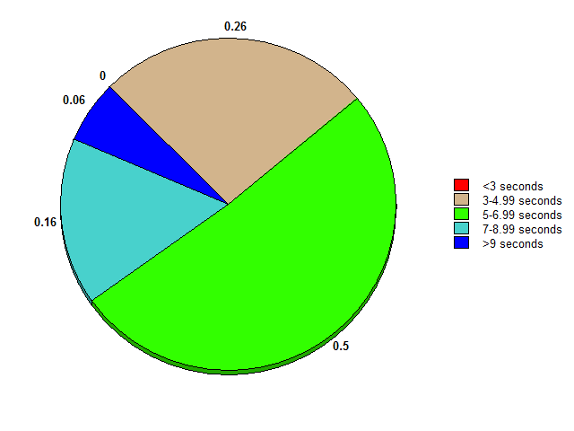

# Average Time by Button

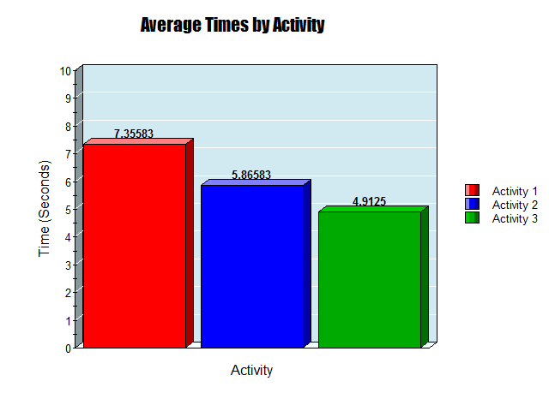

**Summary**:

The study was on the effects that position and image had on an icon’s efficacy. We compared an image of a multicolored mailbox, books, and a green warning sign in that order. The overall findings were that the first icon style was the hardest to see and the third one was the most prefered.

The position of the icon depended on if the participant was left or right handed. Left handed prefered it in the bottom left corner and right handed liked it in the bottom right corner.

For our app we plan to use the third icon and have a setting that allows them to change the position of the help icon.

# Conclusion

Throughout the process we were able to better understand the user audience and tailor our application to their needs. We began with user testing to see from a wide age range what worked best for the user and what features they would expect from an educational app. Originally the plan was to create a voice based application but soon learn there were many downsides to this plan. To begin, an AI capable of this would easily take years to create. On top of this, we felt it would be better based on our audience to have a more novice friendly app. Given the average age demographic of parents that would be using this app, we felt this to be the best approach to be able to bridge the gap between parental learning and their children. We focused on an application that was easy to use, modern, and offers features to help children learn at their own pace on topics they are interested in. SmartSuggest takes what is proven to work in app environments and combines it with features that will keep users coming back to learn more.